Lock 30.0 DLL Instruction

DLL：HNAccessG.dll. Return 0 when success.

***********************************************Note***********************************************
Note1： The HNAccessG.DLL need the support of the files inside the folder "List", please copy the files inside the folder "List" to your executed file directory.

Note2：For Guest Card, when issue "new card", please use the following function to get the RPass based on the current Datatime, and record it. (Different room should have its own RPass). When issue "old card", please use the RPass last time. The "new card " will stop all of the old guests cards.

String CompactCipherTime(TDateTime DT) //Function to creat RPass for the "new card".
{
String Scipher;
char Buffer[16];
DWORD dw;
Word Year, Month, Day, Hour, Min, Sec, MSec;
DecodeDate(DT, Year, Month, Day);
DecodeTime(DT, Hour, Min, Sec, MSec);
dw= (Min/4 )+ Hour*2^4 + Day*(2^9)+ Month*(2^14) +(((Year-8) % 1000)％63)* (2^18);
itoa(dw,Buffer,16);
for(int i=0;i<8;i++)
Buffer[i]=UpCase(Buffer[i]);
Scipher=Buffer;
return(Scipher);
}

Explain:
DWORD, double word;
<<, Left move bit; left move 5bit means multiply 2 power 5;
>>, Right move bit; right move 5bit means divide 2 power 5;
％ Mode;
/ Divide;
itoa, translate Dec to Hex char;

****************************************Function declaration**********************************

1. Key Card, it is used to unlock the lock.

EXTERN_API int WINAPI KeyCard(int Com,int CardNo,int nBlock,int Encrypt,char* CardPass,char* SystemCode,
char* HotelCode, char* RPass, char* Address, char* SDIn,char* STIn, char* SDOut,char* STOut,
int LEVEL_Pass,int PassMode,int AddressMode,int AddressQty,int TimeMode,
int V8, int V16, int V24, int AlwaysOpen, int OpenBolt,int TerminateOld,
int ValidTimes);

Explain:

Com, the COM port to connect the encoder.
CardNo , card number, 1 to 16777215.
Nblock=8. //Default 8, no need change.
Encrypt=88. //Default 88, no need change.
CardPass="33AA9C2693F8" //Default 33AA9C2693F8, no need change.
SystemCode , from Database "HDATA".
HotelCode , from Database "HDATA".
Have to send the database "HData" to the supplier to get the SystemCode and HotelCode.

RPass, the room password, please see the Note2 above.

Address, the lock address, please get this information at Room page of the lock system
(Please see the chart attached below).11 Decimal Code,
"01"(fixed value)+Building(2 number)+Floor(2 number)+Room(3number)+ Door (2 number).
Example "01020300400", Guest Card of Room 4 ,Floor 3,Building2 .

SDIn: The In Date, format "yy-mm-dd", cannot use "yyyy-mm-dd".
STIn: The In Time, format "hh:nn:ss".
SDOut: The End Date, format "yy-mm-dd", cannot use "yyyy-mm-dd".
STOut: The End Time, format "hh:nn:ss".
LEVEL_Pass =3
PassMode= 1, if Terminate old card then PassMode= 2
AddressMode= 0;
AddressQty=1,

TimeMode= 0 // if want the guest card cannot open before check in time, make TimeMode=2
V8,V16,V24 =255.
AlwaysOpen, 1 means always open, 0 means no. Please note that, the Key card with Always function will make the lock always unlock.

OpenBolt, 1 means can open bolt, 0 means no.
TerminateOld, for Guest Card 1 means Terminate the old Guest Card, 0 means no. ValidTimes=255

-------------------------------------------------------------------------------------------------------------------------------------

2. Read Card. It is used to read the card.

EXTERN_API int WINAPI ReadMessage(int Com ,int nBlock,int Encrypt,int* DBCardno,int* DBCardtype,int* DBPassLevel,
char* CardPass,char* DBSystemcode,char* DBAddress, char* SDateTime);

Explain:

Com, the COM port to connect the encoder.
Nblock=8. //Default 8, no need change.
Encrypt=88. //Default 88, no need change.
DBCardNo , card number, read from the card.

DBCardtype, card type, read from the card. undefined yet.
DBPassLevel, undefined.
CardPass="33AA9C2693F8" //Default 33AA9C2693F8, no need change.
DBSystemcode, undefined..
DBAddress, undefined.
SdateTime, undefined.
-------------------------------------------------------------------------------------------------------------------------------------

3. Read Mifare 1 Card Serial Number.

EXTERN_API int WINAPI ReadCardSN(int Com,char* CardSN);

Explain:

Com, the COM port to connect the encoder.
CardSN, the Card Serial Number , read from the Mifare 1 card .

Attached:
See the room information. At the room page, it shows all room information, for example, Room206, Address="01010200600".
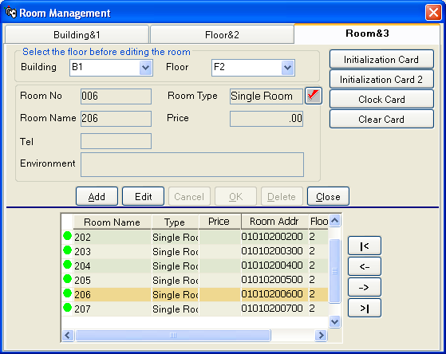
Chart room information

